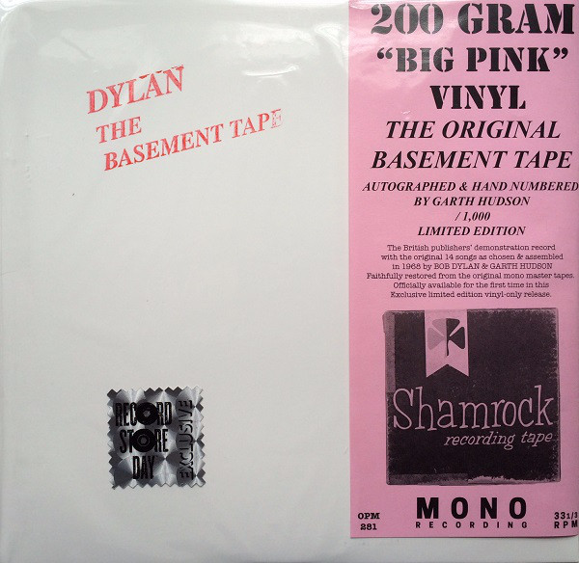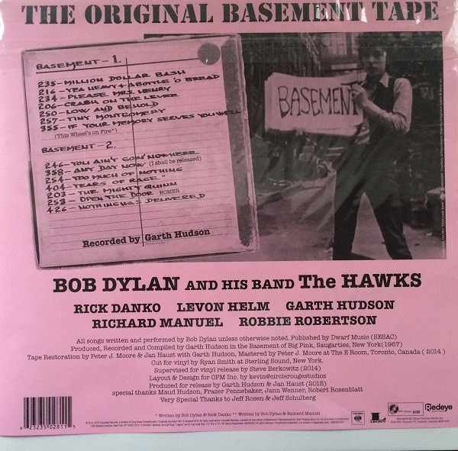

This vinyl version of Bob Dylan’s Basement Tape was created from an original ¼” open reel two-sided tape. Create a record that includes both the original tape and the vinyl record.

Extra credit challenge: if the vinyl tape was then digitized to create MP3 versions of the original songs, how would you add those to the record?

